Navigating the Margins: The Socio-Economic Realities of Street Food Vendors in New Delhi

Anushka Khetawat
Laidlaw Scholar, Barnard College (2024)

TABLE OF CONTENTS:

TABLE OF CONTENTS: 1
ABSTRACT 2
1. INTRODUCTION 3
2. BACKGROUND AND LITERATURE REVIEW 4
3. METHODS 7
4. RESULTS AND FINDINGS 8
4.1. AGE AND EDUCATIONAL BACKGROUND 8
4.2. DAILY INCOME FROM VENDING 10
4.3. MIGRATION AND JOB OPPORTUNITIES 11
4.4. LICENSES AND BRIBERY 14
CONCLUSION 15
BIBLIOGRAPHY 17

ABSTRACT

The informal sector represents a significant portion of the Indian economy, with street vending being a substantial component. This study aims to understand the economics of street food vending in New Delhi by examining the economic implications of operating these businesses in India's capital. By examining factors such as migration, educational background, licensing challenges, and the pervasive issue of bribery, I seek to uncover the motivations behind individuals' entry into this sector and the hurdles they encounter.
I conducted a comprehensive survey involving 40 street food vendors in New Delhi by blending quantitative and qualitative methods to provide in-depth insights into their experiences, challenges, and aspirations. The findings reveal significant barriers to formalization, including complex licensing processes and systemic corruption, while also highlighting the vital role these vendors play in the urban economy. This study contributes to a deeper understanding of the informal economy in New Delhi, offering a nuanced analysis of the potential impacts of formalizing street food vending on vendors and the local economy.
KEYWORDS:
Informal economy, Street vending, Street food vendors, Migration, Economy

INTRODUCTION
The informal sector, often referred to as the shadow economy, plays a pivotal role in the economic fabric of many countries, particularly in developing nations. At present, this sector is characterized by low skill levels, easy entry, low wages, and a predominantly immigrant workforce ¹. Despite these characteristics, the informal sector fills a critical gap in the retail chain by providing essential goods and services to a large segment of the population including the urban poor. This sector, which encompasses street vending, only gained recognition in the early 1970s by a British economic theorist, Keith Hart, while studying economic activities in Accra, Ghana. Hart (1985) used the term to describe various economic activities outside the formal, regulated and taxed economy ². Hart's observations brought attention to a segment of the economy that had previously been overlooked by policymakers and economists alike.
In India, about 90% of the workforce is informal workforce working as self-employed and casual workers ³. A huge part of this informal workforce is formed by street vendors. A street vendor is broadly characterized as an individual who sells goods to the public without a permanent structure, utilizing either a temporary static setup or a mobile stall. These vendors can either be stationary, occupying spaces on pavements or other public/private areas, or mobile, moving from location to location with their merchandise. They may transport their goods on push carts, cycles, or baskets, or even sell them in moving vehicles such as trains or buses.⁴
According to the Food Safety and Standards Authority of India, about 20% of street vendors in the country are made up of street food vendors. This research aims to address the gap in governmental data on street food vendors by studying both licensed and unlicensed vendors in New Delhi. Official records often overlook unlicensed vendors, despite them constituting a significant portion of the street vending sector. These unregistered vendors, who form a substantial part of the urban economy, often operate in legal gray areas, leading to issues such as a lack of access to permits and protection, and regular confrontations with authorities. The study explores the socio-economic backgrounds of these vendors, including their migration patterns, familial history, and education levels, to uncover the factors driving them into this informal sector. By examining these dimensions, the research sheds light on the complex dynamics that compel many individuals to enter street food vending in the face of regulatory challenges.
Key findings from the survey of 40 street food vendors reveal that only 25% hold the mandatory licenses required by the Food Safety and Standards Authority of India (FSSAI) and the Municipal Corporation of Delhi (MCD). The remaining vendors, many of whom migrated from other regions in search of better economic opportunities, must rely on informal networks and regularly pay bribes to operate. These bribes, which range from INR 200 to INR 15,000, are symptomatic of the systemic corruption faced by the unlicensed vendors. Despite these challenges, street food vending in New Delhi offers an essential livelihood to many, providing economic stability for families and contributing to the local economy. This research not only highlights the urgent need for policy reforms but also emphasizes the resilience of vendors who continue to navigate these hurdles in their pursuit of better livelihoods.

BACKGROUND AND LITERATURE REVIEW

There are three primary theories that we can understand to know the informal economy better, the first theory, supported by both Hart and the International Labor Organization, states that the informal sector is a transitory sector that will cease to exist once a country becomes developed, as opposed to remaining a developing country. This approach, known as the dualist approach, assumes that the informal and formal economies are two entirely separate entities and that the informal economy will eventually be absorbed by the formal economy. However, this theory has been proven wrong, given the existence and growth of informal economies even in the most developed countries.
Developed by Castells, Portes, and Benton (1989), the second theory builds on the first and argues that there is a symbiotic relationship between the two sectors. According to this theory, the informal sector is a source for the formal sector, providing manufacturing components at low costs due to less regulation⁵. In this way, the formal economy uses the informal sector to increase profits, while the informal sector depends on the formal sector for its sustenance. This theory remains largely true. Similarly, manufacturers in developed economies often outsource their production to developing countries, where manufacturing in the informal sector is much cheaper than in developed countries.
The legalists represent a third theoretical perspective, pioneered by Peruvian economist Hernando de Soto, renowned for his influential work on the informal economy and urban poverty. According to the legalist theory, the informal sector is comprised of small operators who function outside the formal economy because they find the legal procedures too convoluted to follow⁶. These operators opt for informal operations due to the burdensome, intricate, and challenging government processes required for formal recognition. Thus, these individuals are not deliberately breaking the law but are instead trying to circumvent regulations they perceive as excessively complex and time-consuming.
This theory best explains why street vendors choose to engage in the informal economy. In many instances, street vendors could operate legally by obtaining business licenses. However, this process, when allowed, is highly intricate. It appears that authorities deliberately complicate the licensing process, making it nearly impossible for semi-literate street vendors to comprehend the forms. Completing these forms is even more challenging, a task that most street vendors are unable to manage. It is ironic that while governments strive to streamline processes for large-scale operations in the formal sector, they simultaneously complicate matters for small operators.
The existence of street vendors can be attributed to the essential functions they fulfill for the population. Without demand from the public, street vendors would not thrive. Indeed, they play a crucial role in filling gaps within the retailing chain. Street vendors can be categorized into two main types: those who occupy public spaces such as pavements or parks, and those who are mobile, moving from place to place in search of customers. Despite this distinction, the common characteristic is that their places of business are not permanent.
Street vendors and hawkers have a distinct advantage over shopkeepers in that they actively approach potential customers, whereas customers typically visit shops to make purchases.⁷ This customer-friendly approach was emphasized in a significant decision by the Supreme Court of India, involving a garment seller named Sodhan Singh operating from a pavement in New Delhi. Despite facing frequent evictions and confiscations of their goods by police and municipal staff, street vendors persevere. For the urban poor, street vending offers a means of earning a livelihood with minimal financial investment and low skill requirements. Many street vendors in urban areas are individuals with limited skills who have migrated from rural areas or small towns in search of employment. Street vending becomes an attractive option when other livelihood opportunities are scarce. Although income in this profession may be modest, so too are the investment requirements, and specialized skills or training are not necessary. Thus, for many men and women, street vending represents the simplest means of earning a livelihood.
Although India stands out as one of the few countries that has taken a proactive approach by formulating a National Policy on Urban Street Vendors, implemented in 2004, this policy was designed to strike a balance between supporting the livelihoods of street vendors and addressing urban management challenges¹. It seeks to create a conducive environment that enables street vendors to thrive economically, while also tackling issues related to congestion, public health, and sanitation in urban spaces. The Ministry of Urban Poverty Alleviation, Government of India, has estimated that the total population of street vendors is 10 million, of which 20% i.e. 2 million are street food vendors. The issue with this data is that the government only recognizes street food vendors with licenses which make up a small proportion of the actual population of this section of vendors.
Street vendors in India face significant social challenges, often denied recognition and respect despite their vital role in the economy. They are frequently dismissed as transient entities that will "disappear soon" or seen as nuisances who "have no right to be there." This denial of existence reflects a broader perception among urban elites who view street vendors as eyesores disrupting the urban landscape. In contrast, for the urban poor, street vendors are indispensable providers of affordable goods, conveniently accessible in high-traffic areas. Yet, these vendors are seldom afforded the dignity and tolerance they deserve⁸. They are often targeted by municipal authorities and police as illegal traders, they are criticized by the middle class for obstructing pavements and contributing to traffic congestion, while paradoxically being relied upon for cheaper goods. The contradiction highlights the complex dynamics between the vendors' economic contributions and their marginalization in urban society.
The challenges faced by street vendors extend beyond social perceptions to institutional and legal hardships. Municipal raids, often likened to a cat-and-mouse game, see vendors chased away and their goods confiscated, forcing them to pay heavy fines or resort to borrowing at exorbitant rates to reclaim their livelihoods⁹. The necessity of regularly bribing authorities adds another layer of financial strain, as a significant portion of their income is diverted to maintain their precarious right to operate. This environment of bribery is compounded by discriminatory enforcement practices, where authorities may tolerate encroachments by more privileged groups, such as housing societies and restaurants, while harshly targeting street vendors.
Furthermore, street vendors operate in a legal vacuum where municipal laws lack clear provisions for their existence, and police laws mandate their removal, perpetuating their "illegal" status. This ambiguity allows corrupt officials and politicians to exploit vendors' vulnerability for personal gain. As cities prioritize economic growth over poverty alleviation, eviction drives against street vendors have become more frequent, exacerbating their marginalization. Despite their visible presence in urban life, street vendors are often overlooked in statistical systems and policy-making processes, leaving them in a state of constant uncertainty and harassment¹⁰. The ongoing threat of eviction and the frequent confiscation of their goods make their daily existence precarious, underscoring the need for more inclusive and equitable urban policies.
In light of the challenges faced by street vendors, particularly in the context of urban management and legal recognition, it becomes imperative to understand the socio-economic dynamics that drive individuals into this sector. The informal economy, while often perceived as a transient or peripheral part of the urban landscape, is deeply embedded in the daily lives of millions, offering vital services and employment opportunities, especially to those marginalized by the formal economy. Street vending, as a significant subset of this informal economy, serves as a critical livelihood strategy for many who lack access to more stable and regulated forms of employment. This study aims to shed light on the factors that contribute to the persistence of street vending as an economic activity in New Delhi, despite the numerous social, legal, and institutional challenges that vendors face.
The significance of street vendors extends beyond mere economic transactions; they are integral to the social fabric of urban life, particularly in cities like New Delhi where the demand for affordable and accessible goods is high. However, the legal and institutional frameworks governing urban spaces often fail to accommodate the realities of street vendors, leading to a disconnect between policy intentions and on-the-ground realities. This disconnect not only marginalizes vendors but also exacerbates their vulnerability to exploitation and harassment. By examining the lived experiences of street vendors, this research seeks to contribute to a more nuanced understanding of the informal economy, highlighting the need for policies that are not only inclusive but also responsive to the complexities of urban poverty and livelihood strategies.
As the informal sector continues to play a crucial role in the economic landscape of developing nations, it becomes increasingly important to explore the intersection of migration, occupational choice, and urban survival strategies¹¹. The following sections detail the methodology employed in this study, which combines quantitative data collection with qualitative insights to provide a comprehensive analysis of street food vending in New Delhi. Through this approach, the research aims to offer a balanced perspective on the economic, social, and legal dimensions of street vending, contributing to the broader discourse on urban informality and economic development.

METHODS
I administered a short survey to 40 street food vendors in New Delhi. The survey collected data on various aspects, including the vendors' region of origin (for those not originally from Delhi), age, education level, and the duration of their involvement in street vending. The sampling was done in North, West, South, and Central Delhi, and the respondents’ foods were put into four categories- chaat (snacks), meal foods, momos, and burger/pizza (Figure 1). Additionally, I explored their motivations for entering this sector, their income, working hours, and the fees they pay to the Municipal Corporation of Delhi (MCD) and the police to maintain their operations.

The survey also delved into the respondents' occupational history, including that of their ancestors, the reasons behind their migration, and the factors influencing their occupational choices. I particularly focused on understanding how these vendors accumulated the skills and capital necessary for managing a temporary food stall in New Delhi. Given the sensitive nature of the information being collected, respondents' names were not requested, as preliminary surveys indicated a reluctance to disclose personal identities.

The methodology aimed to balance objective data collection with in-depth interaction. Objective questions were prioritized to gather factual information, while more open-ended discussions allowed for a deeper understanding of the processes and experiences that shaped the vendors' current circumstances. This approach ensured a comprehensive understanding of both the quantitative and qualitative aspects of the vendors' lives, providing valuable insights into the dynamics of street food vending in New Delhi.

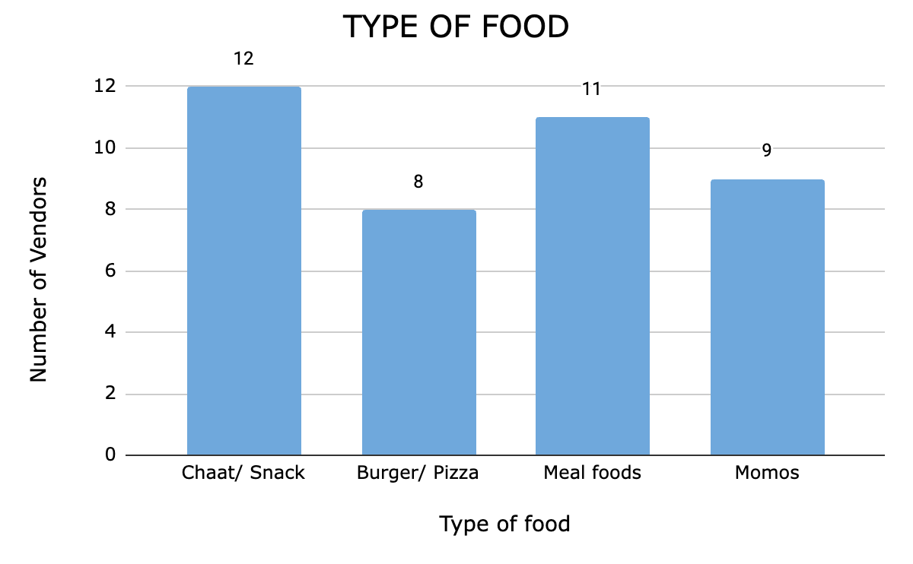
Figure 1

RESULTS AND FINDINGS

AGE AND EDUCATIONAL BACKGROUND

The age (Figure 2) and educational background (Figure 3) of the street food vendors in New Delhi offer key insights into this workforce. The majority are young, with 40% aged 18-25 and 25% aged 26-35, suggesting that street vending is accessible to younger individuals, likely due to its low entry barriers. The remaining vendors are split between the 36-45 age group 20% and those aged 46 and over.

Educationally, 10% of the vendors have no formal education, while 35% have completed primary education (Grades 1 - 8). A significant 22.5% have lower secondary education (Grades 9 - 10), 12.5% have upper secondary education (Grades 11 - 12), and 20% have post-secondary education (Undergraduate and Post-Graduate). This mix indicates that street vending serves as an occupation for those with varying educational levels, from minimal schooling to post-secondary qualifications. The presence of more educated vendors suggests that the sector may also attract those who face challenges in finding formal employment opportunities despite higher qualifications.

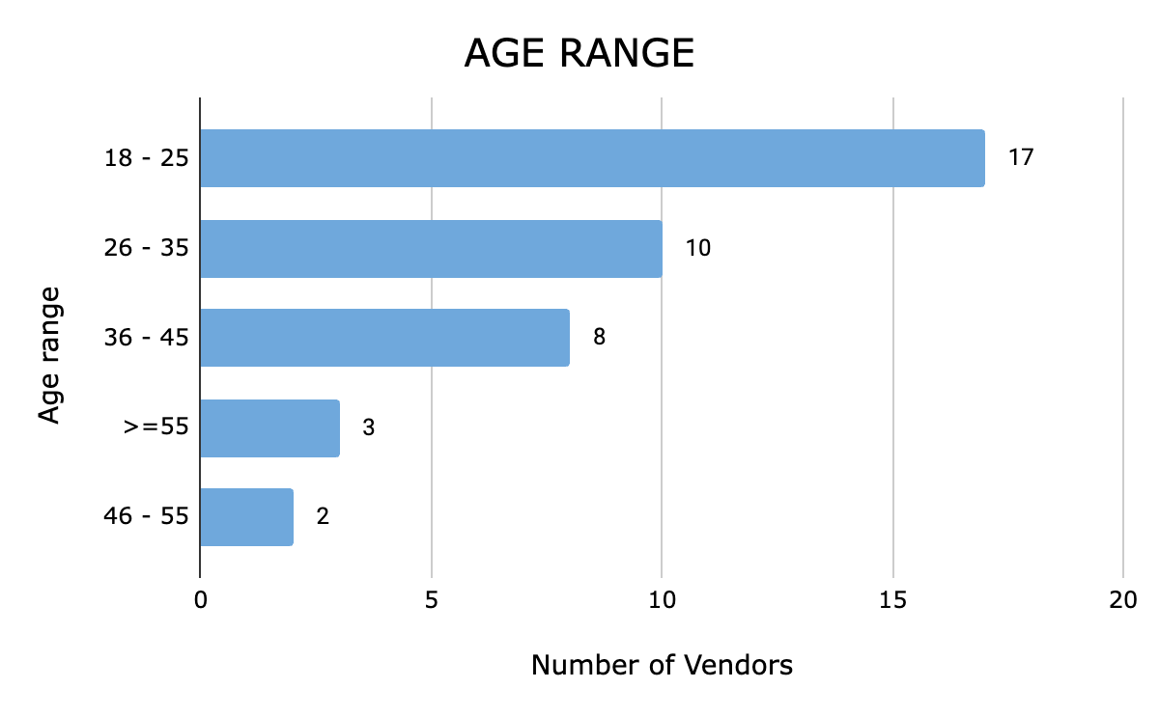
Figure 2

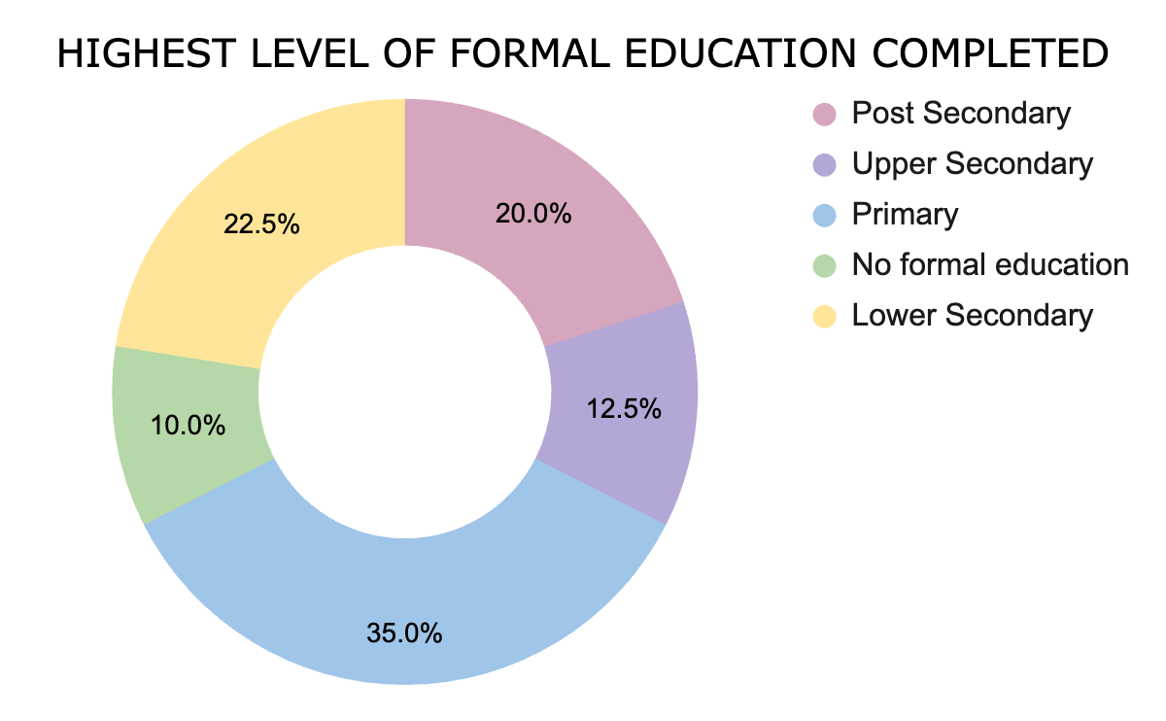
Figure 3

DAILY INCOME FROM VENDING
The daily income distribution of the vendors provides valuable insights into the economic realities of street food vending in New Delhi (Figure 4). The majority of vendors, around 20 out of 40, earn between ₹1,000 and ₹3,000 per day, indicating that street food vending can provide a relatively stable income for many in this sector. However, this income range also suggests that while these vendors may earn enough to cover daily expenses, they likely do not accumulate significant savings, leaving them vulnerable to financial instability in the face of unforeseen expenses or economic downturns.

A smaller group of vendors earns between ₹501 and ₹1,000 (8 vendors), and a few earn between ₹3,000 and ₹5,000 (8 vendors). The disparity in earnings highlights the varying levels of success and profitability within the sector, which could be influenced by factors such as location, the popularity of the food offered, and the vendor's business acumen.

Notably, only a small fraction of vendors (3 vendors) earn between ₹5,000 and ₹10,000 daily, indicating that while there is potential for higher earnings, it is not common. This small group may represent vendors who have managed to establish a more profitable business, possibly through higher-quality offerings, better locations, or more efficient operations.

In contrast, the one vendor earning less than ₹500 per day underscores the precarious nature of street vending for some individuals, who may struggle to make ends meet. This data suggests that while street vending can be a viable livelihood for many, it is not without its challenges, and the income earned can vary significantly depending on multiple factors. Overall, the data reveals a sector characterized by moderate earnings for most, with a few outliers on both the lower and higher ends of the income spectrum.

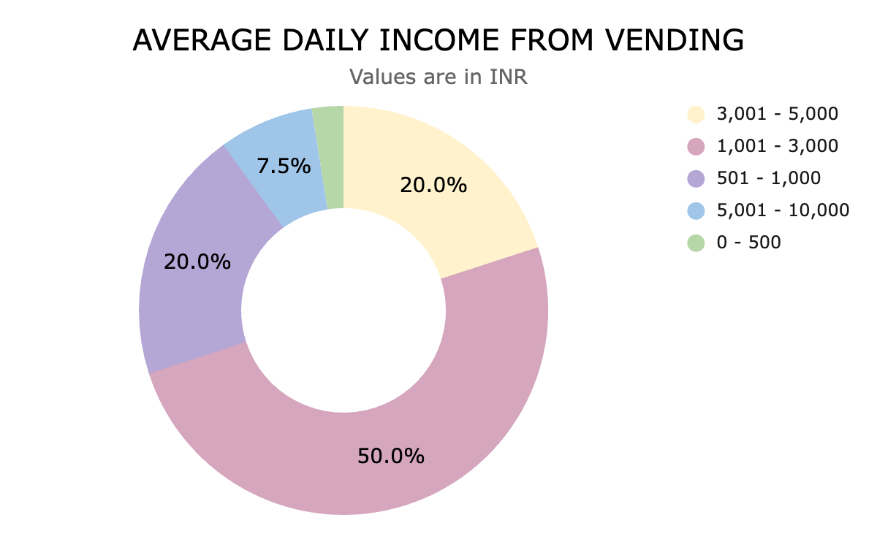
Figure 4

MIGRATION AND JOB OPPORTUNITIES

The data reveals important insights into migration patterns and the quest for job opportunities among street food vendors in New Delhi. A significant 77.5% of the vendors surveyed are not originally from Delhi, with 31 out of 40 respondents having migrated to the city from other states and countries (Figure 5). The primary reason for migration is the pursuit of better job opportunities, as evidenced by the 17 respondents who moved to Delhi for this purpose. This trend underscores New Delhi’s role as a magnet for those seeking to improve their economic circumstances, particularly within the informal sector.

The influence of family is also notable in migration decisions (Figure 6), 22.6% relocated based on advice from family members, while 16.1% of respondents moved to be closer to their families. This indicates that familial connections and support networks play a crucial role in shaping migration choices, with individuals often relying on the guidance or presence of family in their new environment. Additionally, a small portion of 6.5% moved to Delhi for educational purposes, suggesting that for some, migration is not solely driven by immediate economic needs but also by long-term aspirations for self-improvement.

The age distribution of when these migrants moved to Delhi further highlights the patterns of migration. A majority, 51.6%, moved to Delhi between the ages of 18-25, a time when many are entering the workforce and seeking opportunities to establish their livelihoods. The fact that 38.7% of respondents migrated under the age of 18 indicates that a substantial number of individuals start their migration journey early, possibly accompanying family members or seeking work from a young age. The remaining 9.7% of respondents moved between the ages of 26-35, suggesting that migration continues to be an option for those who may have initially pursued other opportunities in their home regions but later decided to relocate.

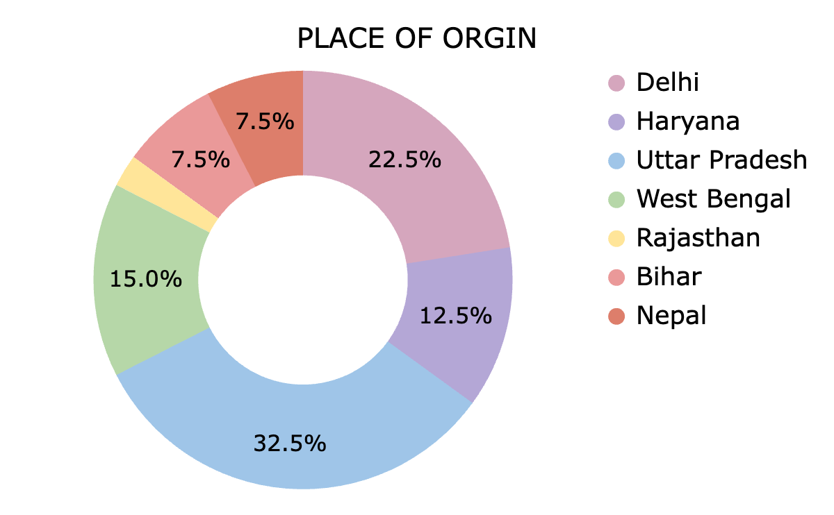
Figure 5

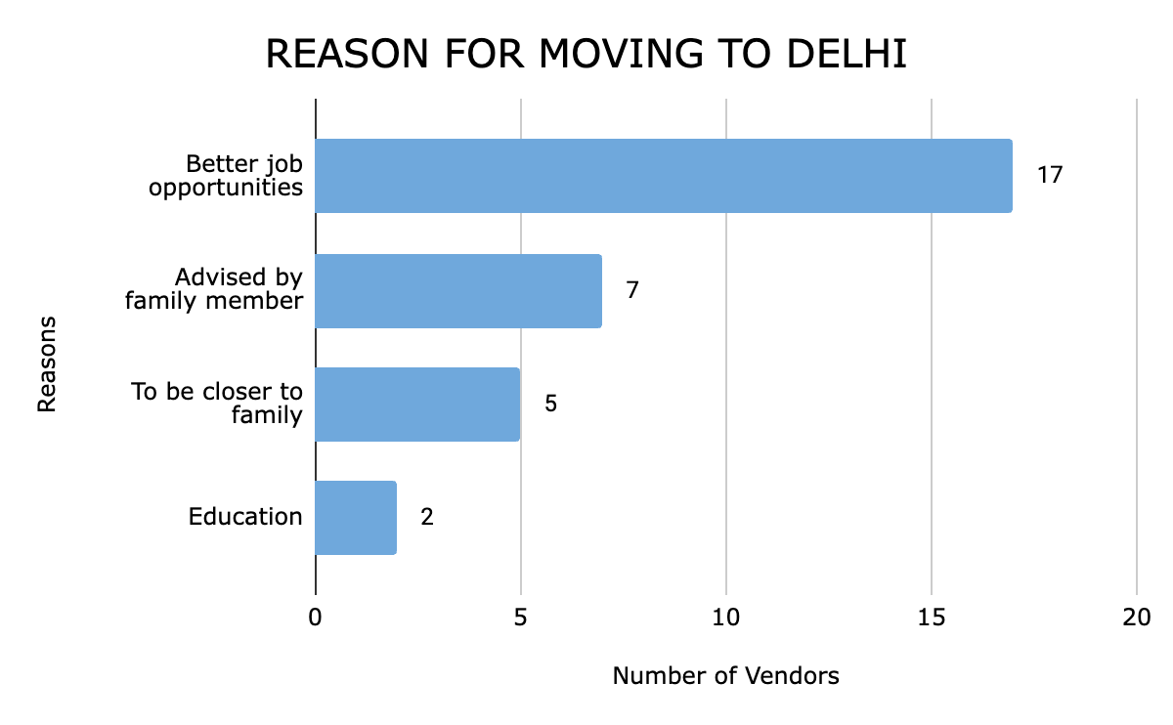
Figure 6

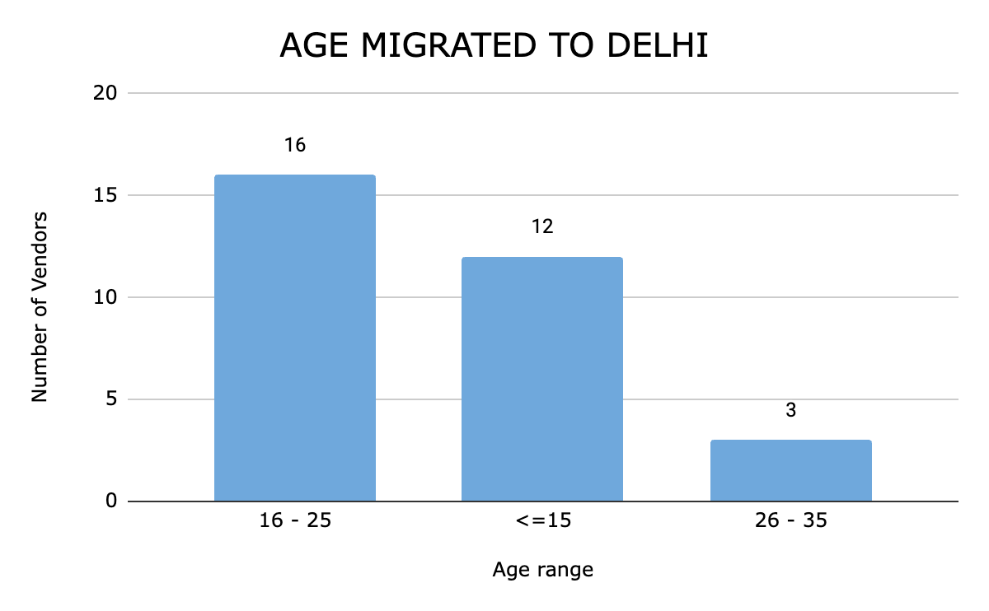
Figure 7

LICENSES AND BRIBERY

Out of the 40 vendors surveyed, only 10 possessed the mandatory licenses required to operate a street food vending business in India, such as the Food Business Operator License issued by the FSSAI (Food Safety and Standards Authority of India) or a trade license from the Municipal Corporation of Delhi (MCD). These 10 vendors either come from families with over 30 years of experience in the trade, spanning multiple generations, or have completed post-secondary education. However, it is significant to note that not all vendors with long-standing family traditions or higher education have obtained these licenses.

Out of the 40 vendors surveyed, 30 (or 75%) admitted to paying monthly bribes to the police and MCD officials to keep their businesses running smoothly. Among the remaining 10 vendors, some were hesitant or refused to disclose information about these payments. The bribes ranged from INR 200 to INR 15,000, with 21 vendors (70% of those who paid) reporting bribes between INR 1,000 and INR 3,000. Four vendors paid less than INR 1,000, while the remaining five paid between INR 3,001 and INR 15,000.

The findings reveal significant implications for the regulation and operation of street food vending in New Delhi. Firstly, the fact that only 10 out of 40 vendors possess the mandatory licenses highlights the pervasive challenges in complying with formal regulatory frameworks. This limited compliance suggests that the process of obtaining these licenses is either prohibitively complex or inaccessible for many vendors, particularly those without extensive family experience in the trade or higher education. The situation underscores the inadequacies of current regulatory policies, which fail to accommodate the realities of street vendors, thereby pushing a large portion of this informal sector into operating outside the legal framework.

Moreover, the prevalence of bribery among vendors further illustrates the difficulties they face in navigating the regulatory environment. With 75% of vendors admitting to paying monthly bribes to police and MCD officials, it is evident that corruption is a significant barrier to fair and transparent business operations. The wide range of bribe amounts indicates a lack of standardization in these illicit payments, which likely depends on the perceived vulnerability of the vendor or the discretion of corrupt officials. This system not only drains the already limited resources of street vendors but also perpetuates their marginalization, as those unable to pay higher bribes may face greater harassment or even the risk of losing their livelihoods.

These implications point to the urgent need for reforms in the legal and institutional frameworks governing street vending. Simplifying the licensing process and reducing bureaucratic hurdles could encourage greater compliance, while stringent measures to curb corruption would help create a more equitable and supportive environment for street vendors. Addressing these issues is crucial for recognizing and legitimizing the contributions of street vendors to the urban economy and ensuring their right to earn a livelihood without undue interference.

CONCLUSION

The findings of this study underscore the significant challenges that street food vendors in New Delhi face, both in navigating complex regulatory environments and in contending with widespread corruption. The data reveals that only a small fraction of vendors possess the mandatory licenses required to operate legally, a situation largely influenced by the vendors' educational background and familial history in the trade. This reflects the broader issue of accessibility and the bureaucratic hurdles that deter many vendors from obtaining legal recognition. Furthermore, the widespread practice of paying bribes to municipal and police authorities underscores the systemic corruption that undermines the vendors' ability to sustain their livelihoods. These payments, which vary widely in amount, add a significant financial burden to an already precarious existence, highlighting the urgent need for reform.

However, it is important to recognize the positive aspects of street food vending in New Delhi. Despite the challenges, many vendors find a means of earning a stable livelihood in this bustling urban environment. New Delhi, with its large and diverse population, offers ample opportunities for vendors to thrive by catering to a wide range of customers, from office workers seeking quick meals to locals craving traditional street food. The city’s vibrant food culture and the high demand for affordable, convenient dining options provide a steady stream of customers, allowing vendors to build a loyal clientele and support their families. For many vendors, being in Delhi means access to a large, dynamic market that helps them sustain their businesses and, in some cases, even pass them down through generations.

However, to improve the working conditions for street food vendors, it is essential to implement a series of targeted interventions. First, issuing permits and designating permanent areas for vendors to set up their stalls would provide much-needed stability and legal recognition. Ensuring that municipal and police authorities do not unjustly ask vendors to vacate or demand bribes is crucial to fostering a fairer and more supportive environment¹². Additionally, helping vendors establish permanent shops could facilitate their transition into the formal economy. The integration of street vendors into the urban landscape requires clear regulatory frameworks at the city level, with transparent rules for space allocation and vendor operations. By addressing the legal ambiguities and conflicting governance over public spaces, as emphasized by the Supreme Court of India, the city can create a more supportive environment for street food vendors.

Effective integration of street vendors into urban landscapes requires the establishment of clear regulatory frameworks at the city level. Municipal authorities must recognize the importance of including street vendors in city policies, with transparent rules regarding space allocation, timing, and vendor numbers. Properly regulated spaces, particularly on pavements, can address many issues by ensuring compliance with legal boundaries, as emphasized by the Supreme Court of India. However, the governance of public spaces must also be clarified, with a focus on resolving conflicting claims between local governments and municipal authorities. By implementing these measures, New Delhi can better support its street food vendors, enabling them to contribute more effectively to the urban economy while safeguarding their livelihoods.

In conclusion, this research sheds light on the complex socio-economic dynamics faced by street food vendors in New Delhi. The informal nature of this sector, coupled with the lack of regulatory clarity and the prevalence of corruption, creates a challenging environment for these vendors. Despite their significant contributions to the urban economy, particularly by providing affordable goods and services to the urban poor, street food vendors continue to operate on the margins of legality and societal acceptance. This research calls for a more inclusive approach to urban planning and policy-making, one that recognizes the vital role street food vendors play in the urban economy and seeks to protect their rights and livelihoods. By adopting these measures, New Delhi can not only enhance the living and working conditions of its street vendors but also strengthen its overall economic fabric.

BIBLIOGRAPHY

- Sinha, Shalini and Roever, Sally. 2011. India’s National Policy on Urban Street Vendors. WIEGO Policy Brief (Urban Policies) No. 2. WIEGO.
- Hart, Keith. “THE INFORMAL ECONOMY.” Cambridge Anthropology 10, no. 2 (1985): 54–58. http://www.jstor.org/stable/23816368.
- A Srija & Shrinivas Shirke, 2014. "An Analysis of the Informal Labour Market in India," Working Papers id:6353, eSocialSciences.
- National Policy on Urban Street Vendors, 2004, Department of Urban Employment & Poverty Alleviation, MUPA, GOI
- Portes, Alejandro, Manuel Castells, and Lauren A. Benton. 1989. The Informal Economy: Studies in Advanced and Less Developed Countries. Baltimore, Md.: Johns Hopkins University Press.
- Bromley, Ray. “A New Path to Development? The Significance and Impact of Hernando De Soto’s Ideas on Underdevelopment, Production, and Reproduction.” Economic Geography 66, no. 4 (1990): 328–48. https://doi.org/10.2307/143968.
- Bhowmik, S. (2010). Street Vendors in the Global Urban Economy (1st ed.). Routledge India. https://doi.org/10.4324/9780203150542
- Gehlot, Ravya, Saejal Kapoor, Gursimran Kaur Butalia and Veenus Jain. “Invisible Entrepreneurs: Unpacking the Challenges of Street Vendors in the Delhi Metropolitan Area.” International Research Journal of Multidisciplinary Scope (2023)
- Dr. V. Jaishankar, Mrs. L.Sujatha, "A Study on Problems Faced by the Street Vendors in Tiruchirappalli City," SSRG International Journal of Economics and Management Studies, vol. 3, no. 9, pp. 40-43, 2016. Crossref, https://doi.org/10.14445/23939125/IJEMS-V3I5P119
- Sharit K. Bhowmik. “Street Vendors in Asia: A Review.” Economic and Political Weekly 40, no. 22/23 (2005): 2256–64. http://www.jstor.org/stable/4416705.
- Kundu, Aditi & Dutta, Sayak. (2020). Migration and Entry to Urban Street Food Market: A Study of Selected Street Food Vendors in Delhi.
- Ehrenfeucht, Renia. “Designing Fair and Effective Street Vending Policy: It’s Time for a New Approach.” Cityscape 18, no. 1 (2016): 11–26. http://www.jstor.org/stable/26328238.

